**6.3 Defense against infectious disease**

**6.3.1Define pathogen. (1)**

* A pathogen is an organism that can cause disease.
* Pathogens include bacteria, viruses, protista, fungi and other parasitic multicellular organisms.

**6.3.2 Explain why antibiotics are effective against bacteria but not against viruses.(3)**

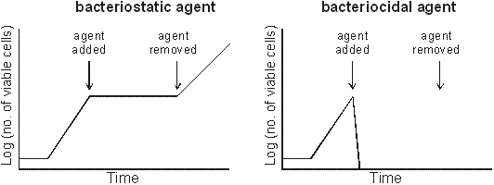**Antibiotics block specific metabolic pathways found in bacteria, but not in eukaryotic cells.**

These graphs show how the two kinds of drug (see below) affect bacterial growth curves.

* Bacteri**cidal** or fungi**cidal** antibiotics kill microbes.
* Others are antibiotics are **static** (bacterio**static**, fungi**static**, etc.), which means they stop further growth, but don't kill existing cells.
* Both are useful medically, because if the growth of an infective pathogen is stopped, the body's immune system will be able to kill it.
* Antibiotics can be selectively toxic by targeting such features as the bacterial cell wall, 70S ribosomes, and enzymes that are specific to bacteria. In this way the human eukaryotic cells are unaffected.

**Viruses reproduce using the host cell metabolic pathways that are not affected by antibiotics.**

* Viruses do not have metabolic pathways like bacteria and therefore antibiotics do not work on viruses.
* Viruses can only be treated by their specific anti-microbial agent and antibiotics should never be prescribed for viral infections (such as flu).

**6.3.3 Outline the role of skin and mucous membranes in defence against pathogens.(2)**

Skin :

* The skin is a tough outer layer called the epidermis, which is 20-30 cells thick whose cells are toughened by the protein keratin. Beneath this is the layer called the dermis (20-40 times thicker) making up the main skin layer and contains sensory receptor cells, blood capillaries and hairs. Deeper down the skin divides to produce new cells which replace those lost from the surface.
* The lining of the lung is another way that pathogen can enter the body. The trachea, bronchi and bronchioles are protected from infection by mucus to which various particles when inhaled. Other cells have cilia, hair like extensions of the cell membrane move the mucus upward to the epiglottis. Here the mixture of mucus and micro-organisms are swallowed down into the acid of the stomach.

**6.3.4 Outline how phagocytic leucocytes ingest pathogens in the blood and in body tissues.(2)**

The second line of defence is the non-specific immune system, a host of quick, non-specific methods of killing microbes that have passed the first line of defence and entered the body.

* 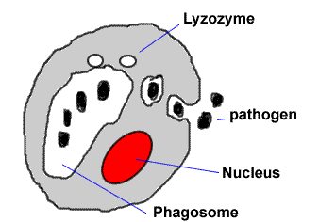Phagocytes are large, irregularly-shaped leukocytes that destroy bacteria, viruses, and dust particles.
* The phagocytes show amoeboid movement, constantly changing shape, as they engulf microbes. The engulf vesicles join together to form phagozomes.
* The phagosome then fuses with lysosomes which contain containing lysozymes. These enzymes killing and digesting the microbes.
* The process is called phagocytosis

**6.3.5 Distinguish between antigens and antibodies.(2)**

**Antigen** is often used to describe something that has infected the body. However it is more accurate to describe them as follows:

* An antigen is a large molecule (protein, glycoprotein, lipoprotein or polysaccharide) on the outer surface of a cell.
* All living cells have these antigens as part of their cell membrane or cell wall.
* The capsid proteins of viruses and even individual protein molecules can also be classed as antigens.
* Their purpose is for cell communication, and cells from different individuals have different antigens, while all the cells of the same individual have the same antigens.
* Antigens are genetically controlled, so close relative have more similar antigens than unrelated individuals.
* Blood groups are an example of antigens on red blood cells, but all cells have them.

The link with infection is that when a pathogen or toxin enters the body it this that the immune system reacts against.

**Antibodies** are proteins secreted from lymphocytes that destroy pathogen and antigen infections

* B-cells make antibodies.
* An antibody (also called an immunoglobulin) is a protein molecule that can bind specifically to an antigen.
* Antibodies all have a similar structure composed of 4 polypeptide chains (2 heavy chains and 2 light chains) joined together by strong disulphide bonds to form a Y-shaped structure.
* The stem of the Y is called the constant region because in all immunoglobulin's it has the same amino acid sequence, and therefore same structure.
* The ends of the arms of the Y are called the variable regions of the molecule because different immunoglobulin molecules have different amino acid structure and therefore different structures.
* These variable regions are where the antigens bind to form a highly specific antigen-antibody complex, much like an enzyme-substrate complex.

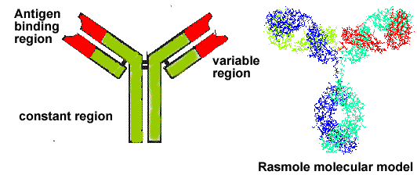

* Each B-cell has around 10 5 membrane-bound antibody molecules on its surface and can also secrete soluble antibodies into its surroundings.
* Every human has around 108 different types of B cell, each making antibodies with slightly different variable regions.
* Between them, these antibodies can therefore bind specifically to 108 different antigens, so there will be an antibody to match almost every conceivable antigen that might enter the body.

**6.3.6 Explain antibody production. (3)**

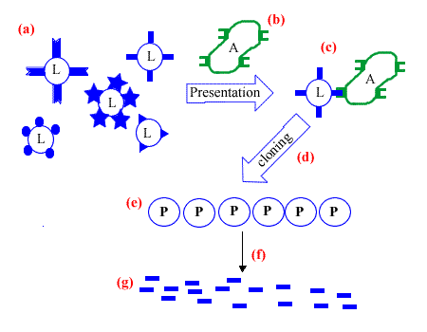**(a)** There are many different lymphocytes.

**(b)** The antigen infects and is presented to the lymphocytes

**(c)** The lymphocyte with a surface epitope complementary to the antigen is selected.

**(d)** The Lymphocyte clones to produce many plasma cells. This occurs in the lymph nodes.

**(e)** The clone of plasma cells

**(f)** The gene for the antibody is expressed and secreted into the plasma and tissue fluid.

**(g)**The antibody circulated in body fluids destroying the infectious antigen

**6.3.7 Outline the effects of HIV on the immune system.(2)**

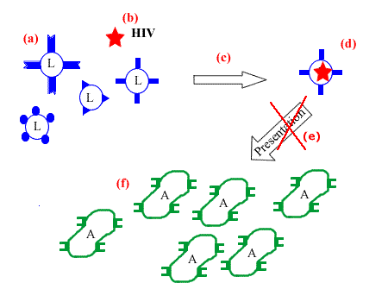HIV is a virus that selectively infects Lymphocytes

**(a)** Different lymphocytes

**(b)** HIV virus

**(c)** Infection as the virus attaches then enters the host lymphocyte.

**(d)** The infected lymphocyte is 'disabled' by the virus

**(e)** When an antigen infection is presented the lymphocyte cannot produce antibodies.

**(f)** The antigen is not challenged by the immune system and is able to freely proliferate

The consequence is that the infected individual will have no immune and develop that disease.

Therefore an individual who is HIV +ve (infected ) will eventually develop a disease which will go unchecked. The consequence is that that disease will severely damage the infected person and will eventually bring about their death.

**6.3.8 Discuss the cause, transmission and social implications of AIDS.(3)**

Social Implications: [Aids takes an economic and social toll by Belinda Beresford Africa Recovery June 2001](http://click4biology.info/c4b/6/images/6.3/151aids9.pdf)

AIDS: **Acquired Immuno deficiency syndrome**.

* ***Acquired*** relates the infectious nature of AIDS through the transmission of the HIV virus.
* ***Immuno* *deficient*** relates to the way diseases cannot be resisted.
* ***Syndrome*** relates to the variation in the way the disease manifest itself. People who develop AIDS can be a affected by quite different set of diseases.

***Cause***: is the HIV retro-virus that selectively infects cells of the immune system effectively disabling primary and secondary response to infection.

***Transmission:*** Through contact with the body fluids of an infected person. In particular the fluids are blood and semen, vaginal mucus. There is a very low risk ( almost zero) associated with salivary mucus.